Name: The Nexus @RPI

Members: Alex Litchfield, Ameya Barve, Nelson So, Catherine Williams, Grace Hui, Angela Imanuel

Summary of proposed project:
“The Nexus @ RPI” is a website application that will allow users to learn more about the RPI campus and resources in a productive manner. The Nexus will have 4 main features: a Professor Picker system, events planner, club/course discussion forum, and health resources. The Professor Picker system allows users to view how well a specified teacher teaches. Additionally, users can also anonymously post their own ratings on a professor’s teaching abilities. Professor Picker differs from other professor rating websites, as this website displays a rating for each class taught by the professor. Currently, popular rating websites only show an overall rating of a professor, which might not be accurate for each class taught by said professors. The events planner feature will allow users to view a list of clubs on campus, and select the ones they are interested in. By doing so, utilizing the Google Calendar API, the club will automatically be added to the user’s Google Calendar. The events will also be displayed on a map via the Google Maps API, allowing users to find the locations of the events easier. The Health Resources pages will provide links to existing resources through RPI or the greater capital region. Each of these resources will have a like to dislike ratio which will allow users to sort based on popularity. Some such resources could be the RPI counseling website, a redirect to the Active Minds events on the calendar, or a redirect to the Sole Survivors events on the calendar.

Personas:
1a) James is a student at RPI who just completed a course and wants to rate their professor and leave a review on how they taught the course for other students
1b) Joshua is a student at RPI who is contemplating taking a course and wants to see what previous students thought about the course and the professor that will be teaching it.
2)Bob has recently started a new club and he wants people to join. He wants to organize club meetings and events but doesn’t know how to start. He learns about The Nexus @ RPI and how he can use it to advertise his club and its events.
3) John is having trouble with homework and wants to be connected with peers in the same class. The Nexus@RPI allows John to have his question be answered by another student who is in the class or has previously taken that class at RPI. Additionally, he can form a study group in Nexus@RPI to help him better understand the content.
4) Becky is struggling with her mental health and would like to seek help, but she doesn’t know what options she has for counseling. She goes to The Nexus@RPI and finds information on walk-in counseling at RPI’s health center and goes. Becky feels better after talking to someone.

Intended Tech.:
CSS, HTML, JavaScript, MySQL, APIs, JSON, and PHP

Functional Requirements:
In our professor rating system users can see a list of all the professors at RPI, or also search for a specific professor. If users click on a specific professor, the classes taught by said professor will be displayed. The user can then choose a class, which will display the professor’s rating in that specific class, along with comments made on the course by previous students. Users can also rate a professor on how they teach a specific class.
In our event planner page, users will be able to see a Google Map of the RPI campus. On this map, the location of various clubs will be displayed. If you click on the club, you can view its description, and also add it to your google calendar. Users can also just see a list of the clubs at RPI.
In our Student Discussion Forum page, users can interact with other users through the forum on this page. There will be a section for users to discuss clubs, and there will also be a section for users to discuss courses. On this page as well, users can join study groups for any class they choose.

Our health resources page will contain information like walkin counseling hours (NEW this semester), help hotlines, and clubs that focus on mental health awareness. We also offer users to more easily find these sources, by offering sorting features based on popularity, time, or subject.
Admins have power to update any section on this website. In the Professor Picker page, admins are able to remove ratings that may be inappropriate. In the Events Planner page, admins can add/delete clubs to the club list. In the Health Resources page, admins can add/delete resources. In the Student Discussion Forum page, admins can delete comments.

Non-Functional Requirements:
We will use HTML, CSS, and JS to display, and search for these professors. We can scrape data of RPI professors from YACS, QUACS, or SIS, in order to get data on each professor at RPI, and then use JSON to store this data. We can use PHP and mySQL to store and display professor ratings.
We will utilize the Google Maps API to display club locations on a map. We will utilize HTML, CSS, and JS, to view a list of clubs, along with their respective descriptions.
For our Student Discussion Forum page, we will utilize HTML, CSS, JS for the visual and interactive aspects of the forum. We will also utilize PHP and mySQL, in order to store info, and retrieve chats from our database. PHP and mySQL will also be utilized for matching students with their chosen groups.
To create our health resources page, we will use HTML, CSS, and JS. We will utilize a JSON file to store links. We will use JS for interactivity for the sorting feature, and the ability to like and dislike different resources will require PHP and mySQL.
For the Admins to be able to add/delete items on this website, we will utilize PHP and mySQL.

Timeline:
September 10th | Project proposal finished
September 17th | Started work on the HTML and CSS
September 24th | Homepage finished
October 1st | Discussion and Mental health front end finished
October 8th | Professor Picker and event planner front end finished
October 15th | Finalize all HTML and CSS and fix bugs
October 25th | All front end (html and css) is completed
November 1st | Started work on back end
November 8th | Finalize mental health resources page
November 15th | Finalize Discussion page
November 29th | Finalize the Professor Picker and event planner backend
December 5th | Front end and back end completed

On September 10th, we will have the project proposal finished and a presentation ready. On October 25th, we will have our HTML and CSS completed. On December 6th, we will have both the front end and back end completed.

IA:
Upon opening our website, the user will be taken to the home page, which will show links to the Discussion Nexus, Health Resources, Event Planner, and RateMyCourseRPI. Our site map is below:
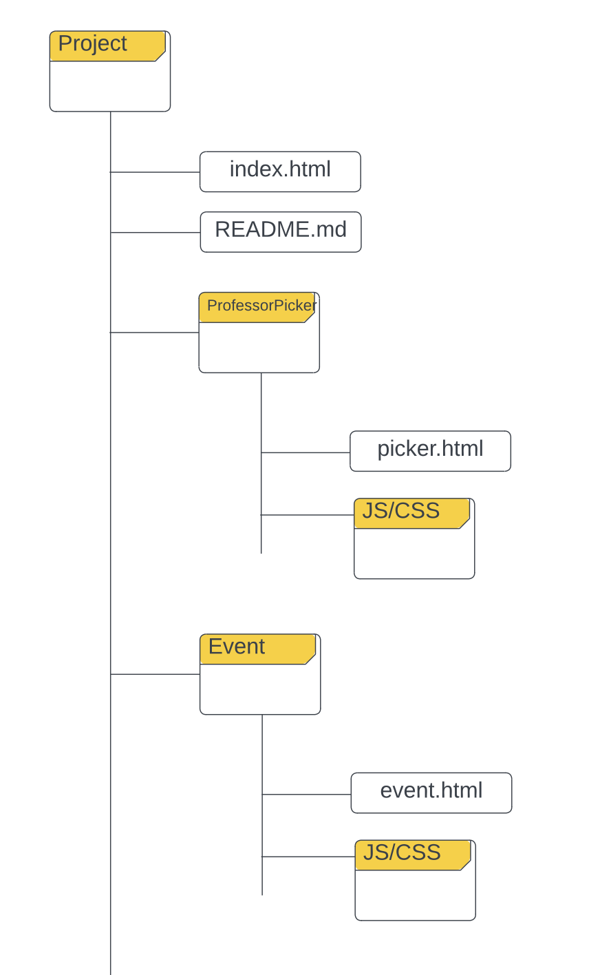
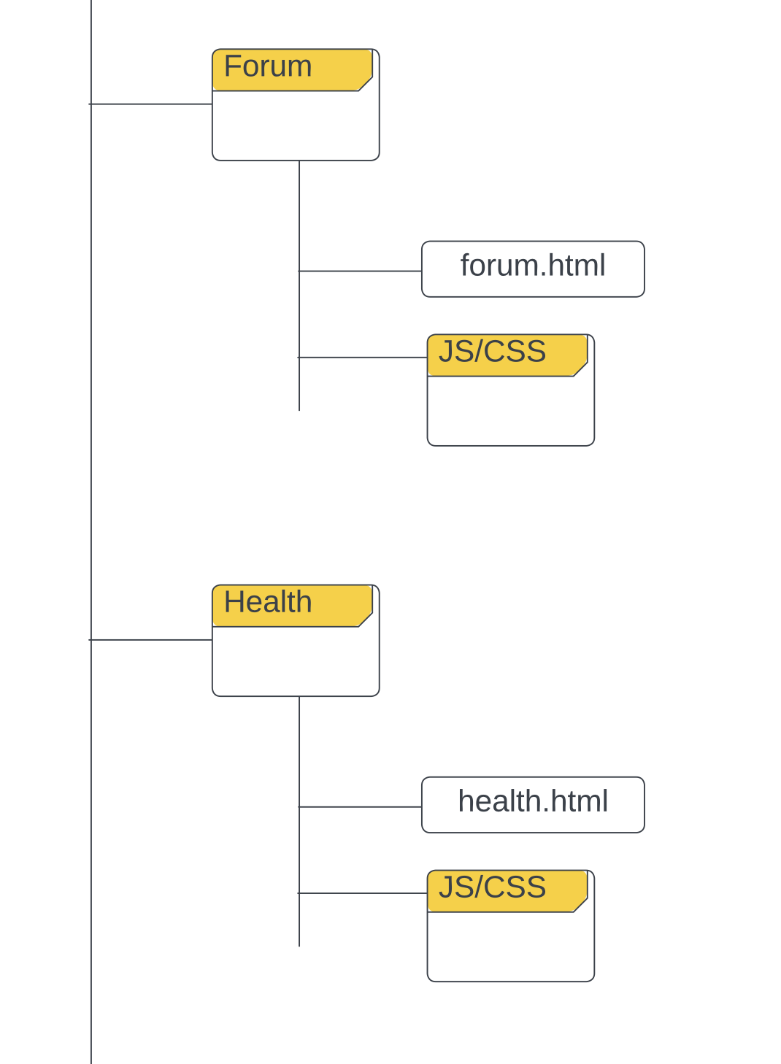
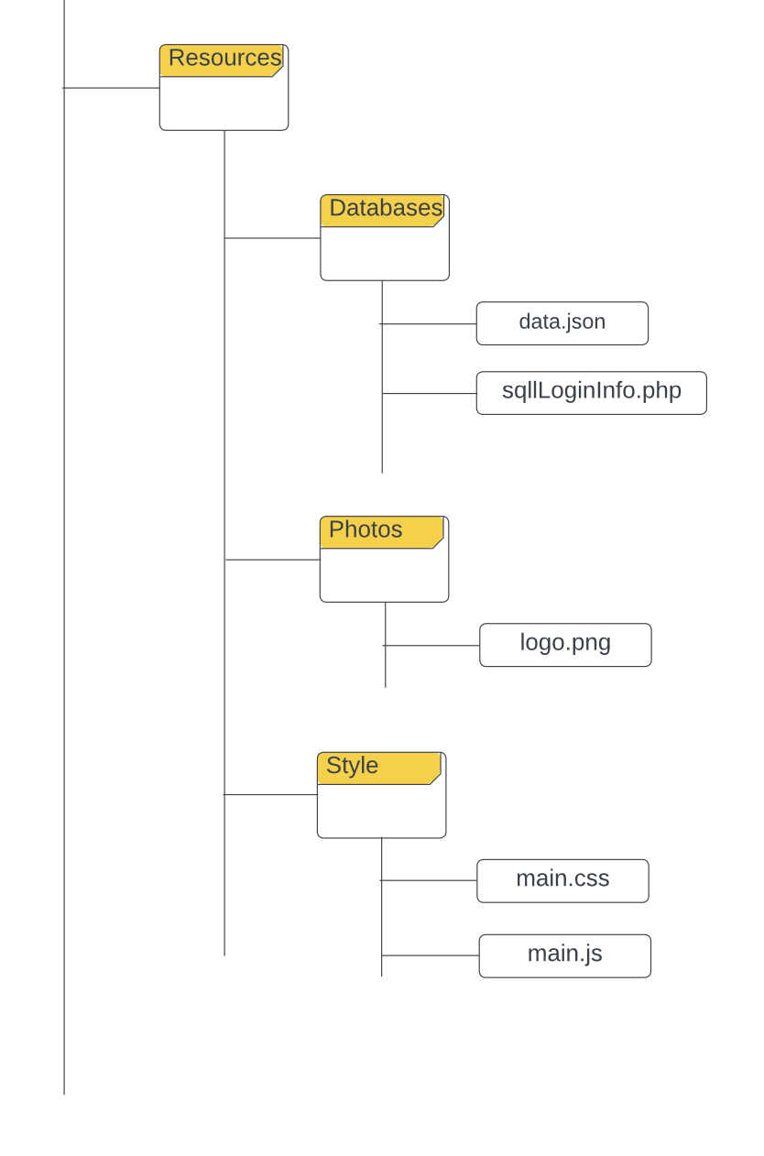

Balsamiq:
Discussion Nexus
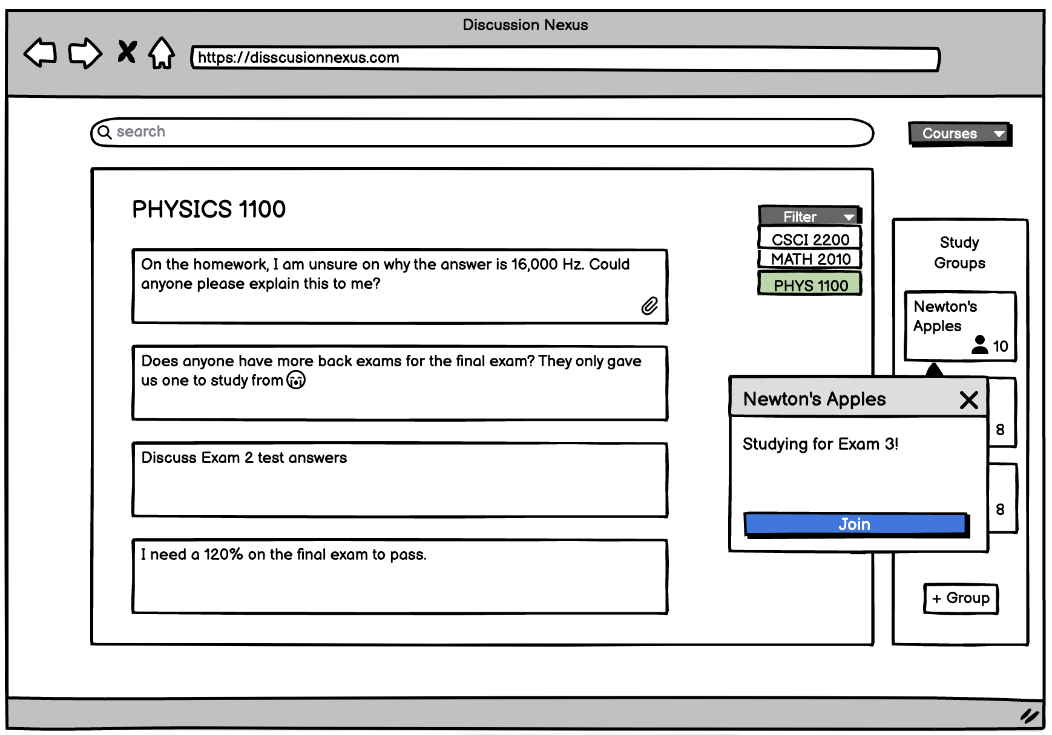
Events Planner
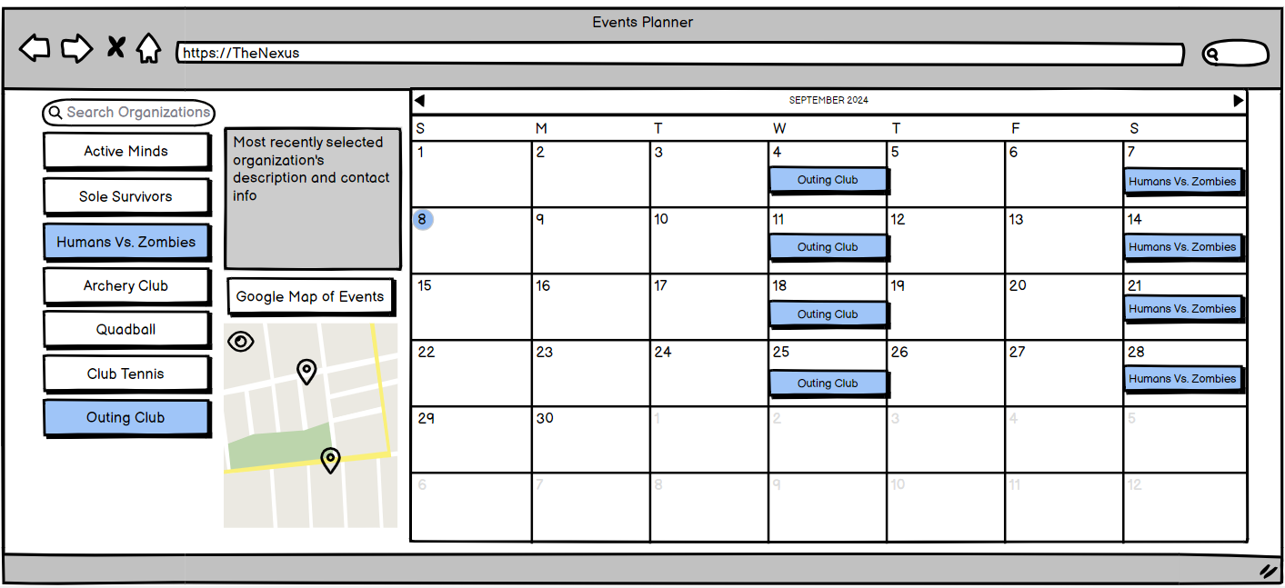

60 sec sell pitch

Presentation

